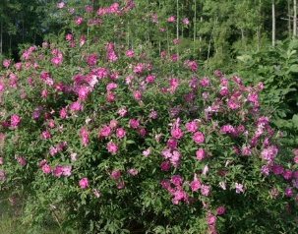
Shrubs – Species offered in 2024
 | Species | Light  exposition | Soil humidity | Size once mature | Ideal shore location | Description
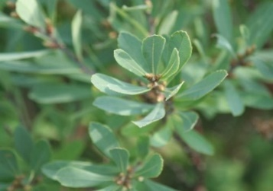 | Sweet gale  Myrica gale |  | High | ↔ 0,6-1,2 m  ↕ 2 m | Lower end of the embankment | - Soil stabilization  - Fragrant  - Suitable for acidic soils
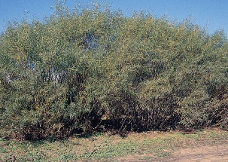 | Sandbar willow  Salix interior |  | Medium to high | ↔ 1-2 m  ↕ 1,5 m | Everywhere | - Soil stabilization  - Provides shade which limits elevated water temperature  - Attracts butterflies
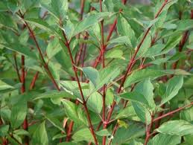 | Red osier dogwood  Cornus stolonifera |  | Low to medium | ↔ 3 m  ↕ 2 m | Everywhere | - Soil stabilization  - Tolerates compact soils  - Suckering plant  - Of interest for birds and butterflies  - Plant ignored by deer  - Fast growth
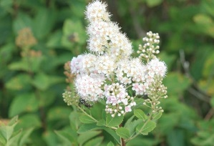 | White meadowsweet  Spiraea latifolia |  | Medium | ↔ 0,6 -1 m  ↕ 0,6 -1 m | Everywhere | - Soil stabilization  - Provides food for fauna  - Produces flowers in early summer
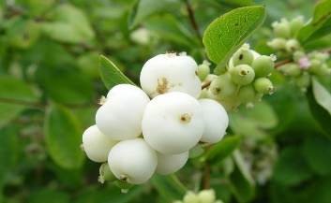 | Common snowberry  Symphoricarpos albus |  | Low to high | ↔ 1- 1,5 m  ↕ 1-1,5 m | Everywhere | - Produces flowers in early summer  - Soil stabilization  - Fast growth  - Provides food for fauna  - Non edible fruits
 | Swamp rose  Rosa palustris |  | Medium to high | ↔1 -2 m  ↕ 1,5 m | Lower end of the embankment | - Suitable for acidic soils  - Fragrant  - Plant resitant to insects and disease  - Produce pink flowers followed by red fruits which stay during winter  - Suckering plant

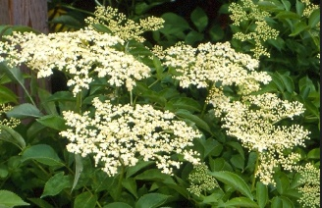
Shrubs (continued) – Species offered in 2024
 | Species | Light  exposition | Soil humidity | Size once mature | Ideal shore location | Description
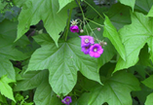 | Flowering raspberry  Rubus odoratus |  | Medium to high | ↔ 1,5-2 m  ↕ 1,5-2 m | Lower end or middle of the embankment | - Soil stabilization  - Small flowers from june to august  - Suckering plant  - Takes expansion  - Of interest for birds and butterflies  - Fragrant
 | Common elderberry  Sambucus canadensis |  | Low to medium | ↔ 1,5-3 m  ↕ 1,5- 2 m | Everywhere | - Soil stabilization  - Fragrant  - Edible fruits  - Leaves can be toxic if ingested  - Provides food for fauna
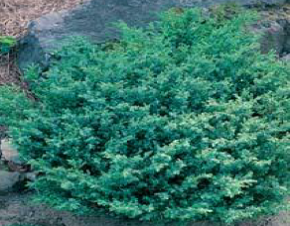 | Common juniper  Juniperus communis |  | Low | ↔ 2,5-3 m  ↕ 1,5-3 m | Top end of the embankment | - Limits soil erosion  - Ground cover plant  - Suitable for rockeries  - Plant ignored by deer  - Fragrant  - Slow growth

Trees – Species offered in 2024
 | Species | Light  exposition | Soil humidity | Size once mature | Ideal shore location |  | Description
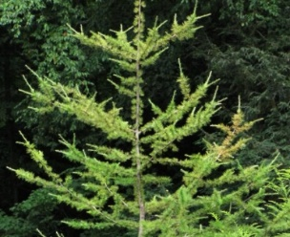 | Tamarack  Larix laricina |  | Low to high | ↔ 15-20 m  ↕ 10-15 m |  | Lower end or top of the embankment | - Provides shade which limits elevated water temperature  - Acts as a windbreaker  - Suitable for acidic soils  - Provides food for fauna
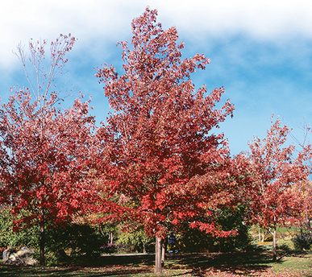 | Red maple  Acer rubrum |  | Medium to high | ↔ 9-20 m  ↕ 15-22 m | Lower end or top of the embankment |  | - Provides shade which limits elevated water temperature  - Minor protection from erosion and ice  - Fast growth  - Provides food for fauna

